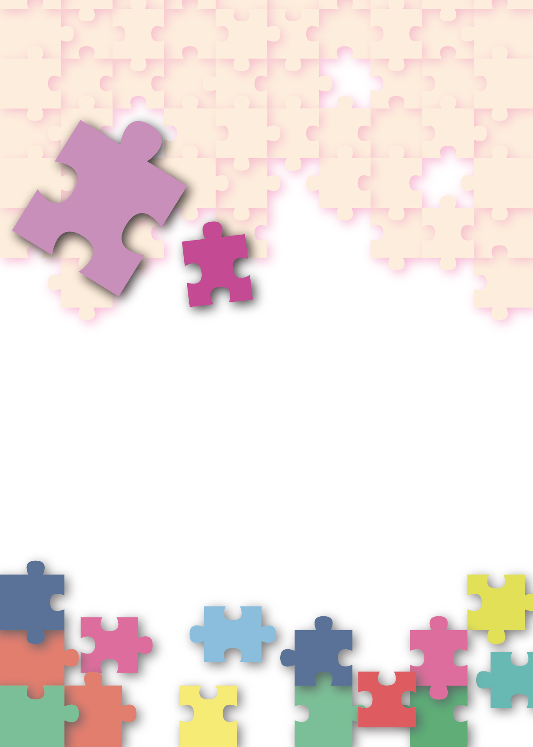
Citizenship, Economics and Society
(Secondary 1-3)
Support Resources
Secondary 3


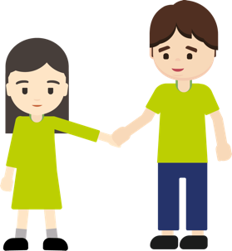



Module 3.1
Intimate Relationships with Affection and Propriety
Part 1:
Proper understanding of love in adolescents
Personal, Social and Humanities Education Section
Curriculum Development Institute
Education Bureau

Introduction

- The “Citizenship, Economics and Society (Secondary 1-3) Support Resources” covers the essential learning contents of Strands 1, 5 and 6 in the Personal, Social and Humanities Education Key Learning Area. It is designed to support the implementation of the Citizenship, Economics and Society curriculum.
- The support resources provide diversified learning activities to help students acquire knowledge and understand concepts, develop skills and nurture proper values and attitudes. In addition, they offer teaching guidelines and suggestions on learning and teaching activities for teachers’ reference. Further, they provide reading materials to enhance students’ interest in reading.
- The Module 3.1 “Intimate Relationships with Affection and Propriety” support resources are made up of a total of 9 lessons, with learning and teaching materials provided in two parts, namely “Part 1: Proper understanding of love in adolescents” taking up 4 lessons and “Part 2: Adolescents and intimate relationships” taking up 5 lessons.
- “Part 1: Proper understanding of love in adolescents” and “Part 2: Adolescents and intimate relationships” of the Module 3.1 “Intimate Relationships with Affection and Propriety” support resources were developed by the School of Education and Languages of the Open University of Hong Kong, commissioned by the Personal, Social and Humanities Education Section, Curriculum Development Institute of the Education Bureau.

Module 3.1 Intimate Relationships with Affection and Propriety
Part 1: Proper understanding of love in adolescents

Contents

Teaching Design | Pages
Lesson 1 and Lesson 2 | 5
Lesson 3 and Lesson 4 | 11
Learning and Teaching Materials
Preface | 13
Worksheet 1: Understanding the differences and similarities between friendship and love | 14
Worksheet 2: Understanding the purpose, principles and proper attitudes of love | 34
Worksheet 3: Understanding the factors that lead to the end of a love relationship and the appropriate ways to handle it | 46
References | 69

Teaching Design:
Topic: | Proper understanding of love in adolescents
Duration: | 4 lessons (2 double lessons are required as conduction of the lesson activities requires more time)
Learning Objectives: | - distinguish the differences between friendship and love  - understand what love is and the goals of love, and proper attitudes towards love

Teaching reminders:
- The study of this module is not intended for encouraging students to start dating or having sexual behaviours early in life. Yet, it is expected that teachers could help students develop a proper understanding of love and responsible intimate relationships and alertness of the consequences of improper handling of intimate relationships, thereby helping them develop gender concepts that are complete and based on mutual respect, uphold proper values and handle topics related to sex and intimate relationships related appropriately.
- Teachers should build on students’ learning in Module 1.1 “Self-understanding and Life Skills” and the learning points “building healthy social relationships and resolving interpersonal conflicts” in Module 1.2 to deepen students’ learning in Part 1 “Intimate Relationships with Affection and Propriety” and Part 2 “Adolescents and intimate relationships” of this module.

Lesson 1 and Lesson 2
Pre-lesson Preparation: | Students shall finish the following before the class:  - Read Worksheets 1 to 2 and complete the activities.
 |  | Suggested lesson time
Enquiry Process: | - Set: The teacher explains the meaning and impact of friendship and love at the stage of adolescence; and invites students to share their daily life examples and personal experiences of friendship and love, and brings out the message that possessing proper values of friendship and love helps us grow. | 5 minutes
Enquiry Process: | - Interactive teaching:  - Direct instruction: The teacher briefly introduces Knowledge content in Worksheet 1 “Understanding the differences and similarities between friendship and love” to guide students to understand the differences and similarities between the two and the need to set limits of intimacy.  - Pair work: Students work in pairs to discuss “Activity 1: Love or friendship” in Worksheet 1. The teacher invites several groups of students to share their answers. The teachers can use “Socrative” or a show of hands to understand students' choices and deepen their understanding of the differences and similarities between friendship and love.  - Teacher debriefing: The teacher asks students:  - Do you easily confuse friendship and love?  After the debriefing, the teacher shall introduce the next part of teaching. | 10 minutes
Enquiry Process: | - Interactive teaching:  - Direct instruction: The teacher introduces the content of “Activity 2: Similarities and differences between friendship and love” in Worksheet 1, and guide students to understand the importance of friendship and love to individuals and how they affect their future lives.  - Pair work: Students work in pairs to discuss first part of “Activity 2” and share the discussion results.  - Group presentation and class discussion: The teacher invites each group to present. Discussion results from different groups, questions raised by the teacher and peers and their own reflections will help students deepen their understanding of the differences and similarities between friendship and love*.  *Teachers uses Appendix 1 “Know more: Is there really pure friendship between men and women?” to help students understand the value of friendships with the opposite sex and how they can help young people grow and further examine their own relationships with the opposite sex.  - Group discussion: Students work in groups of four to five to discuss and categorise the second part of Activity 2.  - Group presentation: The teacher invites different groups to present their discussion results. Students listen to the discussion results of different groups and reflect on the questions raised by the teacher and peers, which help students deepen their understanding of the differences and similarities between friendship and love from a rational perspective.  - Teacher debriefing: The teacher points out to students that Activity 2 in Worksheet 1 has helped them preliminarily understand and distinguish the similarities and differences between friendship and love, as well as cultivate proper values including rationality, respect, commitment, etc. Then the teacher shall introduce the next activity to enable students to analyse and understand the elements of friendship and love. | 10 minutes
Enquiry Process: | - Interactive teaching:  - Direct instruction: The teacher briefly introduces Appendix 2 “Know more: Like or love?” and Activity 3 in Worksheet 1 to guide students to think about the difference between like and love. The teacher invites some students to share their answers.  - Video watching and direct instruction: The teacher shows students the “3-minute Concept” animated video clip “Triangular Theory of Love”, to introduce the Knowledge content of the Triangular Theory of Love and to guide students to understand that friendship and love are composed of different elements and bring out the importance of setting limits of intimacy.  - Teacher debriefing: The teacher points out to students that Activity 3 in Worksheet 1 has helped them recognise the elements of friendship and love, as well as cultivate proper values including rationality, respect, commitment, etc. Built on this learning, the teacher shall introduce the next activity to enable students to preliminarily understand the purpose of love. | 15 minutes
Enquiry Process: | - Interactive teaching:  - Direct instruction: The teacher introduces the content of Worksheet 2 “Understanding the purpose, principles and proper attitudes of love”, and guide students to discuss the common reasons for falling in love, so as to introduce the next part of teaching.  - Student reflection: The teacher guides students to complete “Activity 1: Love is...”, invite several students to share their understanding and views on love, and use the reflection questions to guide students to understand the importance of love and the possible impacts of false love concepts.  - Teacher debriefing: The teacher points out to students that Activity 1 in Worksheet 2 has helped them preliminarily understand the purpose of love, as well as cultivate proper values including respect, treasure, responsibility, etc. Built on this learning, the teacher shall introduce the next activity to enable students to further understand and learn to uphold the principles of love. | 10 minutes
Enquiry Process: | - Interactive teaching:  - Direct instruction: The teacher introduces the content of “Principles of love” in Worksheet 2, and guides students to think about how to have a proper attitude towards love.  - Interactive game: The teacher introduces “Activity 2: The game of the scale of love principle”. Students share their standpoint of statements about love relationships. The teacher reminds students to follow their own mind and respect classmates.  - Student reflection: The teacher invites students to share their reasons for choosing the standpoint of love. The teacher invites students having two different standpoints respectively to share their views.  - Teacher debriefing: The teacher points out to students that Activity 2 in Worksheet 2 has helped them recognise the principles of love, as well as cultivate proper values including rationality, self-control, empathy, etc. Built on this learning, the teacher shall introduce the next activity to enable students to recognise the methods for maintaining love relationships. | 15 minutes
Enquiry Process: | - Interactive teaching:  - Direct instruction: The teacher introduces the contents of “Maintaining love relationship” and “Tips for love relationships” in Worksheet 2, and guides students to think about the manifestation of the principles of love.  - Group discussion: Students work in groups of four to five to discuss and analyse Worksheet 2 “Activity 3: Tips for love relationships”. *  *The teacher may select one or two cases for discussion, and those not discussed may be used for homework to consolidate learning.  - Group presentation and class discussion: The teacher invites each group to present their discussion results. Students listen to the discussion results of different groups and reflect on the questions raised by the teacher and peers.  - Teacher debriefing: The teacher points out to students that Activity 2 in Worksheet 2 has helped them recognise the methods for maintaining love relationships, as well as cultivate proper values including respect, treasure, responsibility, etc. | 10 minutes
Enquiry Process: | - Summary:  - The teacher summarises the learning points of this lesson that are to distinguish the differences between friendship and love, to understand what is love and its purpose and the attitudes that need to be upheld.  - The teacher encourages students to reflect on the importance of proper principles and attitudes in developing love relationships, and their impact on maintaining love relationships. | 5 minutes
Extended Learning Activity: | The teacher shall ask students to read Appendix 1 “Know more: Is there really pure friendship between men and women?” and Appendix 2 “Know more: Like or love?” after school.
Learning and Teaching Resources | Worksheets 1 to 2; Appendices 1 and 2; “3-minute Concept” animation video clip “Triangular Theory of Love”

Lesson 3 and Lesson 4
Pre-lesson Preparation: | Students shall finish the following before the class:  - Read Worksheet 3 and complete the activities.
 |  | Suggested lesson time
Enquiry Process: | - Set and revision: The teacher reviews the key learning points of Lessons 1 and Lesson 2 with students. | 10 minutes
Enquiry Process: | - Interactive teaching:  - Direct instruction: The teacher briefly introduces the Knowledge content of Worksheet 3 “Understanding the factors that lead to the end of a love relationship and the appropriate way to handle it”, and guides students to understand the impact of a break-up and the importance of handling it appropriately.  - Group discussion: Students work in groups of four to five to discuss and analyse the cases provided in Worksheet 3 “Activity 1: Breaking up properly”. *  *The teacher may select some cases for discussion, and those not discussed may be used for homework to consolidate knowledge.  - Group presentation and class discussion: The teacher invites each group to present their discussion results. Students listen to the discussion results of different groups and reflect on the questions raised by the teacher and peers, which will deepen their understanding of factors that lead to the end of a love relationship and the importance of handling it properly.  - Conclusion: The teacher debriefs students on the activity and asks students:  - Have you ever been bothered by the experience of having difficulty in breaking up rationally?  After the debriefing and questions, the teacher introduces the next part of teaching. | 30 minutes
Enquiry Process: | - Interactive teaching:  - Direct instruction: The teacher briefly introduces the content of “Appropriate handling methods” and “5W1H to end a love relationship” in Worksheet 3, and guides students to think about how to appropriately end a love relationship.  - Group discussion: Students work in groups of four to five and use the method “5W1H to end a love relationship” to discuss and analyse the case provided in “Activity 2: Break-up assessment report” in Worksheet 3.*  *The teacher may select some cases for discussion, and those not discussed may be used for homework to consolidate knowledge.  - Group presentation and class discussion: The teacher invites each group to present their discussion results. Students listen to the discussion results of different groups and reflect on the questions raised by the teacher and peers, which help students deepen their understanding of how to end love relationships appropriately and the consequences of inappropriate handling of love relationships. | 30 minutes
Enquiry Process: | - Summary:  - The teacher summarises the learning points of this lesson.  - The teacher encourages students to develop proper attitudes and principles of love and to become more aware of the consequences of inappropriate ways of ending love relationships. | 10 minutes
Extended Learning Activity: | Students read Appendix 3 “Know more: The Break-up Agent” after school
Learning and Teaching Resources | Worksheet 3; Appendix 3

Module 3.1 Intimate Relationships with Affection and Propriety
Part 1: Proper understanding of love in adolescents
(Lesson 1 and Lesson 2)
Learning and Teaching Materials
Preface
Young people may have been very familiar with the discussion on whether secondary school students should engage in love relationships. Further discussion on the topic nowadays should focus on what it means to be in love and how to cultivate an appropriate attitude towards love. Young people need to have a proper understanding of love relationships, the differences and similarities between friendship and love, and the meaning and impact of love relationships on adolescents, so as to help them build healthy interpersonal relationships.

As adolescents enter puberty, they begin to develop an interest in the opposite sex and are full of romantic fantasies about love; they easily fall in love with others and wish to make friends and develop relationships with the opposite sex. All these are important developmental tasks of adolescence.

However, young people's attitudes and values towards friendship, love and marriage are often influenced by the mass media, the Internet and popular culture, and thus can easily become confused or misled. The basic emotions associated with friendship and love are the basic emotions that are an integral part of life. Therefore, we need to help young people develop positive ideas about interpersonal relationships, so that they understand that all interpersonal relationships have their own principles and that upholding an attitude of respect is essential to the growth of interpersonal relationships.
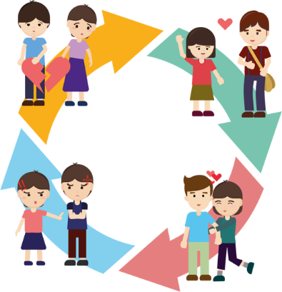
On the other hand, as young people do not have enough life experience, they may not know how to cultivate, maintain, or end a love relationship, so they may easily express their feelings in an impulsive or extreme manner, which may cause harm to both parties. Therefore, it is important to develop a proper attitude towards love, not only to know how to get along with your lover, but also to review the development of the love relationship in a timely manner, so as to avoid tragedies arising from a fading relationship.

This resource will help young people differentiate friendship and love, and understand the elements and meaning of love, the purpose of love, the attitudes that should be adopted, the factors that lead to the end of a relationship and the appropriate ways to deal with the end of a relationship, so that young people can learn how to avoid setbacks in love relationships, which may affect their views on love and their future growth.

Learning and teaching activity suggestion: The teacher shall have students complete Worksheets 1 and 2 before class, and then discuss the activities and summarise the discussion results in class.

Worksheet 1: Understanding the differences and similarities between friendship and love

Both friendship and love are based on emotions that young people face in their developmental stages. They may be based on the same foundation of mutual admiration, like-mindedness or concern, but the development and form of the two kinds of relationships are different. In Secondary 1 Module 1.2 (Part 2) “Friendship”, we discussed the importance of friendship in personal development, and how adolescent girls and boys begin to be curious about the opposite sex and are eager to develop friendship and love relationships with the opposite sex. The differences and similarities between friendship and love, and how to distinguish and even draw the line between them, are essential lessons in interpersonal relationships.

Friendship

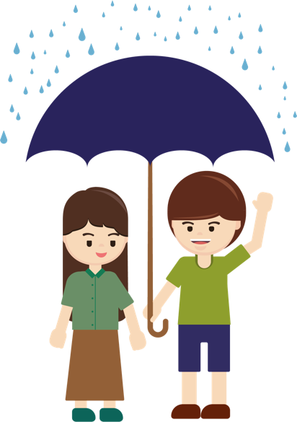


Love


Knowledge content 1: The similarities and differences between friendship and love

The basic affections associated with family, friendship and love relationships are an integral part of our lives. It is important to differentiate between friendship and love so that we don't put the wrong affections into our relationships. The following are similarities and differences in friendship and love:
 | Aspect | Friendship | Love
Similarities | Emotional foundation | Friendship and love must be based on mutual understanding, trust and inclusiveness.
Differences | - Number of target people | Friendship is more open to a wide range of people, and is more acceptive of others. | Love is exclusive. There is only one partner and no third person should be allowed to interfere.
Differences | - Level of commitment | Friends are willing to give to each other. | Love creates mutual admiration and a willingness to give to each other, which can go deeper than friendship.
Differences | - Sense of security | Friends need to feel secure, but usually to a lesser extent than lovers. | Lovers usually need a greater sense of security.
Differences | - Way of getting along | Individual or group activities are acceptable to friends. | Individual dating for lovers is the common activity.
Differences | - Goals and persistence | Friendships can be deep or shallow, and are usually about getting along well and compatibility; and people are more accepting of fading friendships due to change of circumstances. | Love is a relationship that grows deeper and deeper, often with marriage as the ultimate goal, and it is expected that the relationship will not change as circumstances change.
Differences | - Level of difficulty when ending a relationship | It’s easier to make sensible choices and decisions about relationships in a friendship. | It is often difficult to make rational choices in a love relationship.
Table 1 Similarities and differences between friendship and love



Activity 1: Love or friendship

Teaching reminders:
Teachers should adopt a prudent and objective attitude, as well as listen and understand students’ needs, doubts or difficulties open-mindedly and carefully, to help students discuss the topic of gender issues with a responsible attitude and to enable students to construct a proper understanding of love and understand responsible intimate relationships by analysing relevant learning scenarios and listening to teachers’ debriefing.
Teachers should remind students that when they encounter personal problems, they can seek help and suggestions from professional counselling, teachers, social workers and family members.

Based on the clues in the case photos below, determine their relationship, point out the clues and provide reasons.
Photo (example) | What does the photo show about their relationship?
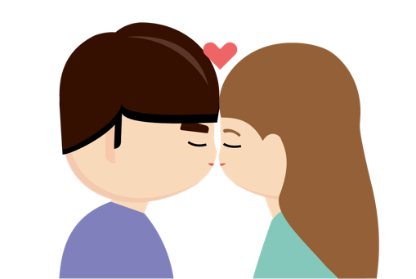 | Friendship
 | Love
Clues and Reasons:
Kissing is an intimate act between lovers.

Photo 1 | What does the photo show about their relationship?
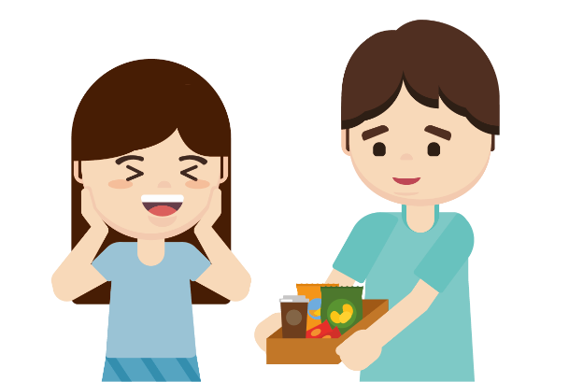 | Friendship
 | Love
Clues and Reasons:
Bringing food to someone in a fast food restaurant is a common behaviour between lovers/friends.

Photo 2 | What does the photo show about their relationship?
 | Friendship
 | Love
Clues and Reasons:
Taking selfies/intimate photos is a common practice between lovers.

Photo 3 | What does the photo show about their relationship?
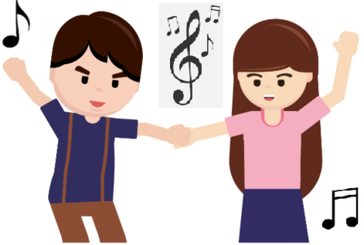 | Friendship
 | Love
Clues and Reasons:
Lovers/friends can dance together.

Photo 4 | What does the photo show about their relationship?
 | Friendship
 | Love
Clues and Reasons:
After puberty, when a man and a woman hold hands, it is a sign of a more intimate relationship.

Activity 2: Similarities and differences between friendship and love
Learning and teaching activity suggestion: Students can refer to Module 1.2 (Part 2) “Friendship” for a review of learning content on friendship.

Source 1: 20 years of friendship remains unchanged as young man with rare disease volunteers to care for wheelchair-bound friend every day
What is friendship? With changes in time and circumstances, friendship may change, but true friendship will last forever. Diagnosed with rare spinal disease at the age of three, Yeung Siu-on has been battling the disease for over 20 years and his weight once dropped to 20kg. He has to use a wheelchair to get around and needs help with eating and getting dressed. In addition to his mother, who is always there for him, he also has a good friend who is like a brother to him, Kim, whom he has known for over 20 years. Kim and Siu On met when they were in primary school and their relationship has remained unchanged through secondary school and later in society. Kim has rare disease, which causes obstruction of the airway due to a small jaw and a prolapsed tongue, accompanied by difficulty breathing and difficulty eating. Although he has difficulty speaking, he still helps feed and dress Siu On and takes him around in his wheelchair in his spare time. Every day after work in Kowloon, Kim would rush to Siu On's home in the New Territories to take care of him, rain or shine. To Siu On's mother, Kim's presence was like having a son, and to Siu On, Kim was a friend to cherish for the rest of his life. When asked why they became friends, Siu On said it was due to their similar interests and age, and that good friends may not be around every day, but they are always there when needed.

Source: Excerpted and adapted from Hong Kong Economic Times (27 February 2020), 20 years of friendship remains unchanged youngster with rare diseases take care of friend in wheelchairs every day.

Source 2: Over 100-year-old couple married for 79 years, the oldest living couple in the world

Some say that marriage is the tomb of love. How to spend the rest of your life with the one you love and live it to the fullest without regrets is one of life's greatest questions. An Ecuadorian couple who has reached the age of 100 have become the oldest couple in the world. Married for 79 years, the husband is now 110 and his wife 104, and they are still very much alive and well. It all started when Tapia, aged 31, secretly married Reis, then 25, ignoring the objections of her family, and they became the oldest couple in the world. They met on holiday and remained friends for seven years before getting married. Reis said she fell in love with his loving and often young soul, while Tapia said he was captivated by her beauty and always felt her generosity and determination during their long conversations. Their relationship is full of love, which has allowed them to get to know each other and grow emotionally, something that has not come easily and which can only be achieved with time and persistence. When asked about their marriage, they said that love, understanding and honesty are the keys to a happy and long-lasting marriage.

Source: Excerpted and adapted from Hong Kong Oriental Daily (27 August 2020), Female college student can't bear her boyfriend cheating and breaking up, receiving 60 abusive text messages a day, harassing and jumping off the building.
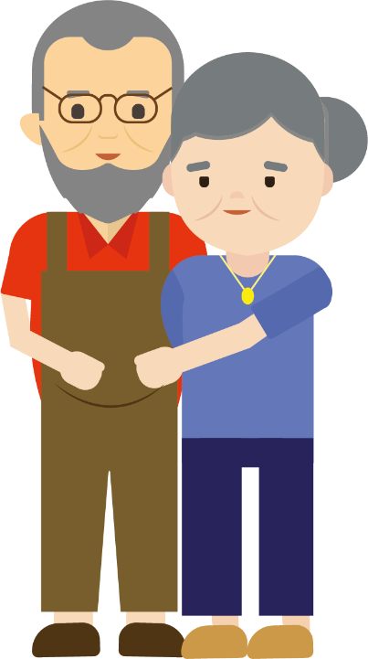
Part 1: In pairs, read Sources 1 and 2, discuss and summarise the characteristics related to friendship and love. Try filling in your discussion results in the boxes below and presenting them to the class.
Love
Friendship

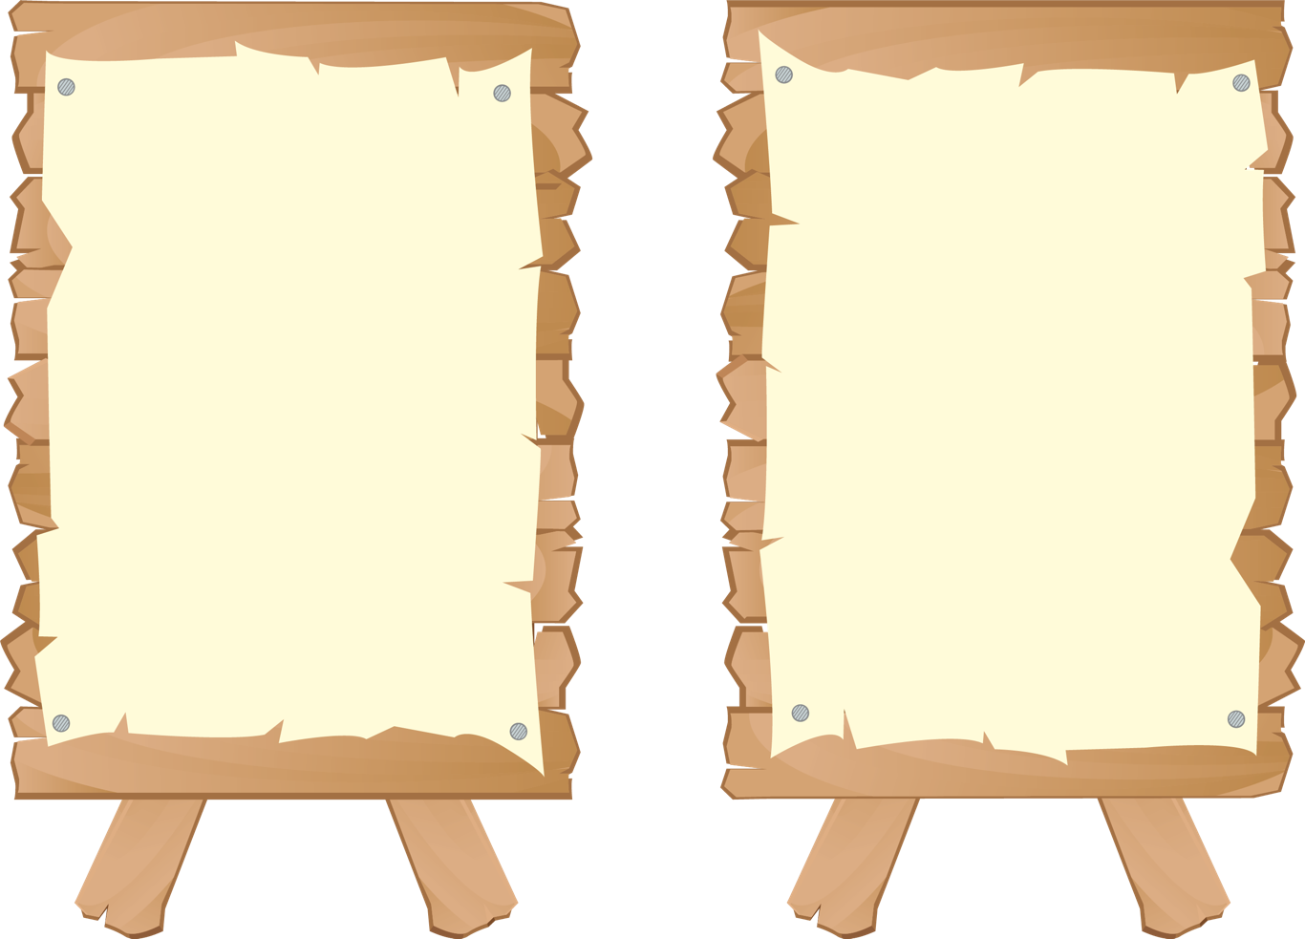

- Similar interests, similar age
- Care about each other and help each other out (we are always there for each other when we needed help)
- Keeping in touch with each other (every day after work in Kowloon, Kim would rush to Siu On's home in the New Territories to take care of him, rain or shine)
- Cherish friendship (To Siu On, Kim is a friend to cherish for the rest of his life)
- Mutual attraction (Reis and Tapia are attracted to each other)
- Intimacy
- Willingness to give to each other
- Desire for more affections
- Lifelong commitment and love, understanding and honesty are the keys to a long-lasting marriage




Learning and teaching activity suggestion: If necessary, the teacher may use the information in the brackets to explain.
Discussion:
- What do you think are the differences between friendship and love?
Suggested answer:
- In terms of the number of target people: Friendship is more open to a wide range of people, and friends are willing to accept others. Lovers are exclusive. There is only one partner and no third person should be allowed to interfere.
- In terms of level of commitment: Friends are willing to give to each other. Love involves mutual admiration and lovers are willing to give to each other in the love relationship, which can go deeper than friendship.
- In terms of sense of security: Friends need to feel secure, but usually to a lesser extent than lovers; lovers usually need a greater sense of security.
- In terms of getting along: Individual or group activities for friends; mostly individual dating for lovers.
- In terms of goals and persistence: Friendships can be deep or shallow, and are usually about getting along well and compatibility, and people are more accepting of fading friendships due to circumstances change. Love is a relationship that grows deeper and deeper, often with marriage as the ultimate goal, and it is expected that the relationship will not alter as circumstances change.
- In terms of level of difficulty when ending a relationship: Friends are more likely to make sensible choices and decisions about relationships; it is often difficult for lovers to make rational choices about their relationships.

- If young people are confused about the concepts of friendship and love, how will this affect their interpersonal relationships?
- Approaching love with an attitude of developing friendship can lead to a causal relationship that does not go far and deep enough.
- Approaching friendship with an attitude of developing love can easily lead to misunderstanding and failure to set the right limits of intimacy.



Appendix 1
Know more: Is there pure friendship between men and women?

Friendship is the foundation of most love relationships. However, sometimes the line between friends and lovers can be blurred, and many of us have questions about how to define and go beyond this line. In this regard, the University of Wisconsin invited 88 pairs of opposite-sex friends to conduct a survey and found that women are more likely to focus on spiritual communication and believe in pure friendship.

In contrast to women, men tend to believe that platonic friendship is more difficult to maintain. Platonic friendship refers to close relationship between people of the opposite sex that does not involve sex. Men tend to see platonic opposite-sex friendship as an opportunity to start a romantic relationship. Women, however, seem to think very differently and see platonic friendship as pure friendship.

True pure opposite-sex friendship helps us gain different perspectives from our friends of the opposite sex and learn how to relate to the opposite sex during adolescence. Some opposite-sex friendships also involve one or both partners wanting to take the friendship further and turn it into a love affair. In true pure friendship, both partners want to maintain the friendship and simply see each other as good friends, caring for each other and growing together. As the friendship deepens, opposite-sex friends can become closer to each other and together they can keep the friendship alive.
Do you believe in pure friendship between men and women?

Source: Excerpted and adapted from Ward (2012), Men and women can't be “just friends” .
Do you think heterosexual friendships affect a person's romantic relationship?


The teacher may show the EDB Educational MultiMedia – “Getting along with opposite sex” (Chinese version only), and discuss with students the similarities and differences between friendship and love, and the right attitude towards sexuality
https://www.hkedcity.net/etv/resource/435889116
Part 2: Do you know the difference between friendship and love? Try comparing the two with a Venn diagram and fill in the circles with the similarities and differences.


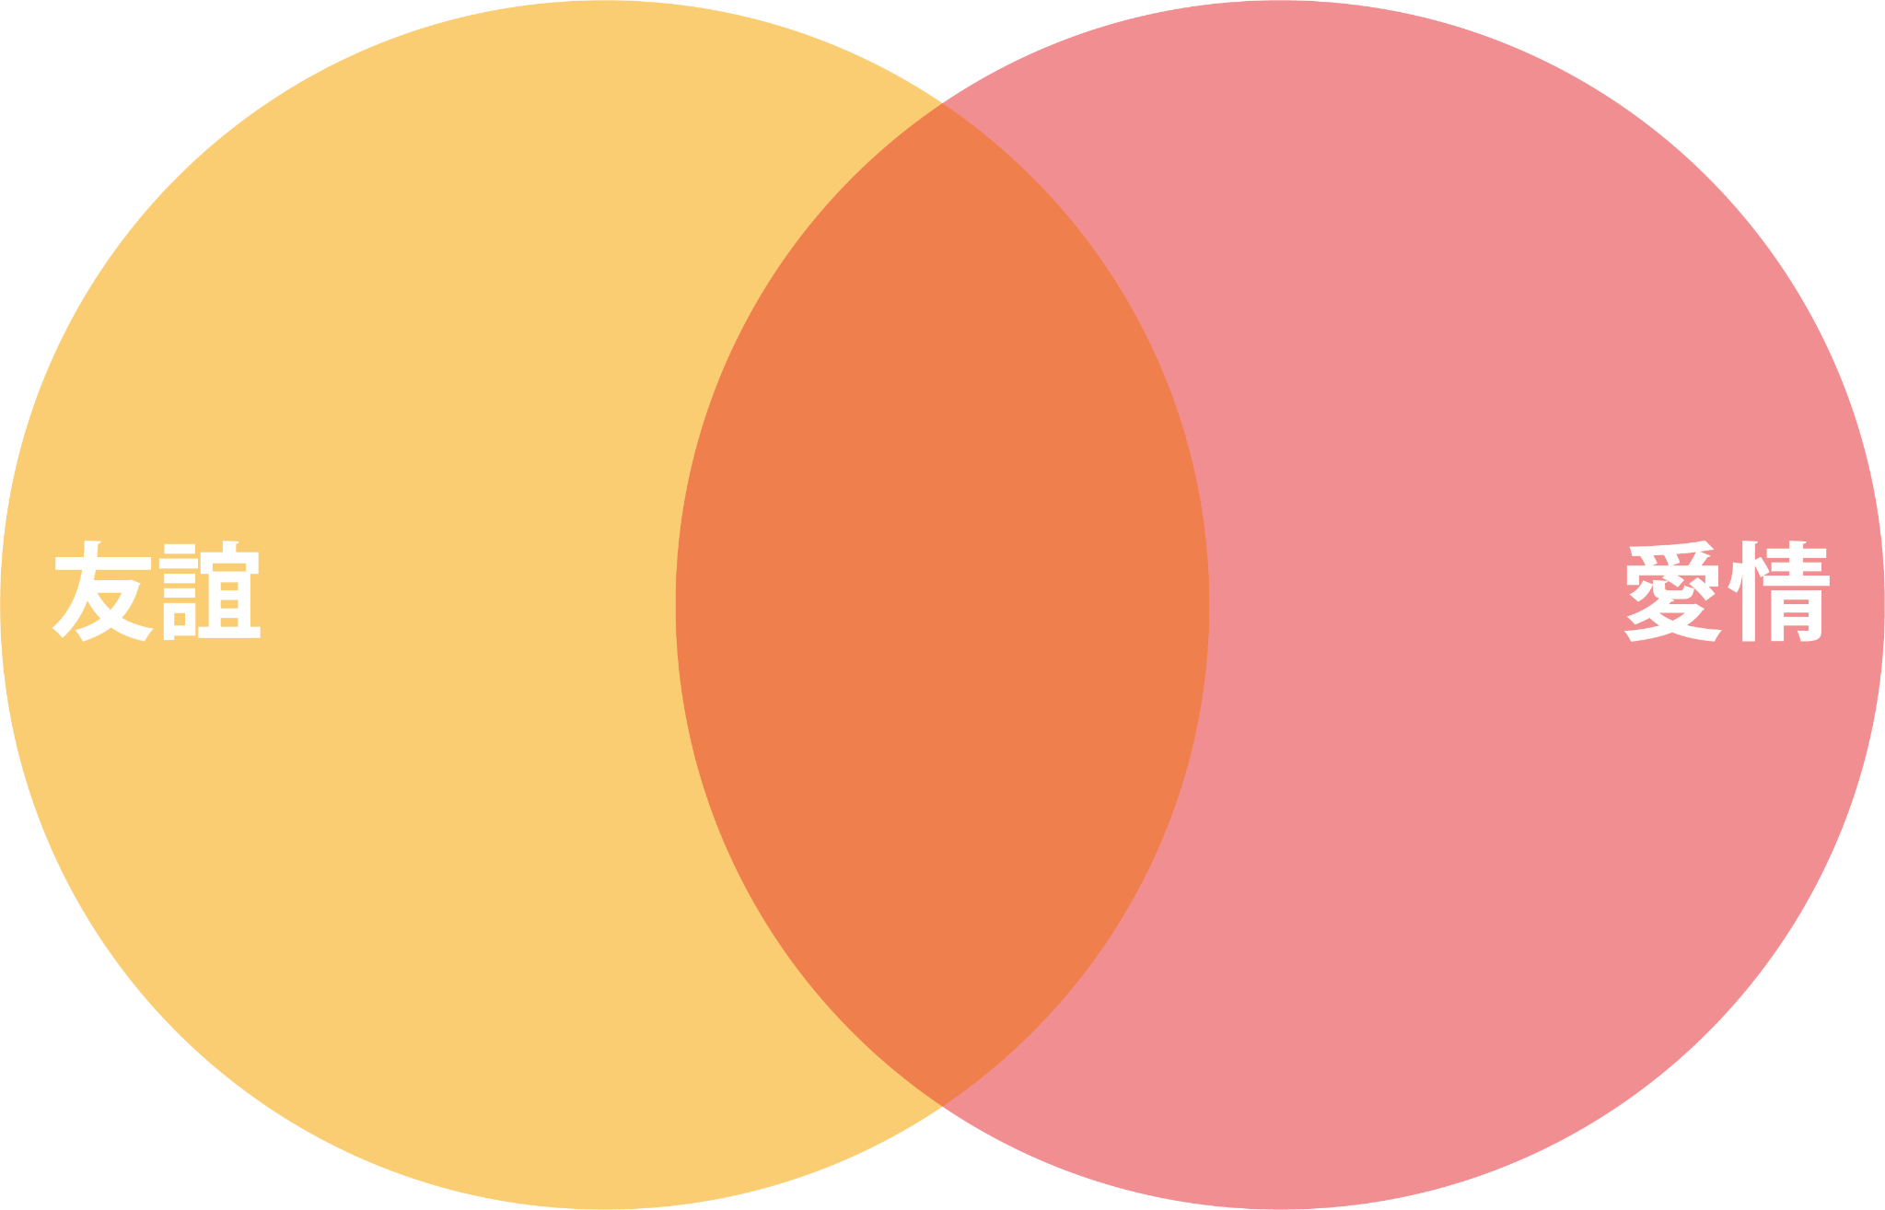
- Devoted to only one partner, and no third person is allowed to interfere
- Involve various considerations (age, level of mutual understanding, commitment, social acceptance, etc.)
- Need to be serious about a love relationship as it is not easy to meet, develop and maintain/end such a relationship
- Expect more from a partner in a love relationship than a friend, and lovers want to have a long and close relationship, and see a cooled off love relationship as problematic
- Need to cultivate and give deeply
- Mostly have marriage as the long-term goal
Friendship

Love
Similarities
- Based on trust, understanding, respect and tolerance
- Need to feel safe, support each other, and give to each other
- Seek long-term relationships
- Involve giving each other joy, satisfaction and care, and growing together
- More open to a wide range of people, and friends are willing to accept others
- Friends generally seek for mutual understanding, getting along well and support
- Involve more group activities, and friends are acceptive for outsiders to join
- Can be deep or shallow
- Does not have gender restrictions
- Can be maintained through daily communication, gatherings, etc.
- Easy to start, develop, maintain/end, and can be more spontaneous
- Does not need frequent contacts

Teaching reminders:
When the teacher conducts debriefing, he/she should point out the proper values learned from the topic, that is, respect, commitment, etc., are important for interpersonal relationships, especially love relationships; and should explain to students the following important points:
- Whether it is friendship or a love relationship, it must be built on trust, understanding, respect and inclusiveness;
- Should know that people involved in a love relationship needs a sense of security, support from each other, and devotion to each other;
- Should seek long-term relationships but not temporary pleasure;
- Be considerate of the other person's feelings and ready to give support and care, so that they will grow together.

Know more: Like or love?
In the 1970s, the American social psychologist Zick Rubin tried to study how love affects interpersonal relationships and understand how these affections arise. Rubin argued that “love” and “like” are two different feelings with different components, with “like” favouring friendship and mutual admiration but without strong attachments. Based on this logic, Rubin developed the “Love Scale” in the hope that the results of the scale could be used to identify or assess the nature of the relationship.

Appendix 2

Like
Love




Activity 3: Like or love?
Think of a person and put a “” in the boxes on the following two scales for the answers that match your feelings.
Love-scale |  | Like-scale
- If he/she is in a bad mood, I will comfort him/her right away. |  | - When I am with him/her, we are almost in the same mood.
- I can tell him/her almost everything. |  | - I think he/she is emotionally stable.
- It's easy for me to ignore his/her mistakes. |  | - I'm pretty sure he/she can do a job that requires a lot of responsibilities.
- I would do almost anything for him/her. |  | - In my opinion, he/she is a mature person.
- I would like to have him/her all to myself. |  | - I trust his/her good judgment.
- I would feel miserable if I could never be with him/her. |  | - Many people will like him/her very soon after getting to know him/her.
- When I am lonely, he/she is the first person I look for. |  | - I think he/she is very similar to me.
- I am very concerned about his/her well-being. |  | - I will vote for him/her in class or group elections.
- I will forgive anything he/she does. |  | - I think he/she is someone who can easily win the respect of others.
- I feel responsible for his/her happiness. |  | - I think he/she is quite a smart person.
- When I'm with him/her, I spend a lot of time looking at him/her. |  | - He/she is the cutest person I know.
- I would be happy if he/she told me the secret. |  | - He/she is exactly the kind of person I want to be.
- Without him/her, my life would be miserable. |  | - In my opinion, he/she is easily admired by others.
Total: ／13 questions |  | Total: ／13 questions

Source: Rubin (1970), Measurement of romantic love.
Do your answers fall in the “like” side or “love” side?

Grading criteria:
The list of items with more “” represents how you feel about him/her.

Teaching reminders:
When the teacher conducts debriefing, he/she should point out the proper values learned from the topic including rationality, respect, commitment, etc., and that “love”, as compared to “like”, emphasises long-term and responsible relationships. The important points include:
- Care about each other's happiness more than one’s own comfort;
- Learn from each other to let the other take up an important position in one’s life;
- Because “love”, as compared to “like”, has stronger attachment, we have to consider when we lose “love”, we will feel very lost. Therefore:
- Should not start intimate relationships casually;
- Should consider the other’s pain when losing attachment in a love relationship;
- When it is absolutely necessary to end a love relationship, people involved should do their best to reduce the pain arising from the loss of attachment.

Knowledge content 2: Triangular Theory of Love

Have you ever heard that there are types or modes of love? Watch the animated video clip “Triangular Theory of Love” from the “3-minute Concept” and answer the questions below.

Intimacy
Complete
Love
Passion
Commitment

Figure 1 Sternberg's “Triangular Theory of Love”
The teacher can play “3-minute Concept” Animated Video Clip Series - Triangular Theory of Love (Chinese version only) to introduce the knowledge content of Triangular Theory of Love.
https://emm.edcity.hk/media/生活與社會「三分鐘概念」動畫視像片段系列：（2）愛情三角理論/1_7q5qfk0e

Sternberg, an American psychologist, developed the Triangular Theory of Love, which suggests that “complete love” consists of three elements: intimacy, passion and commitment.
- Intimacy: Intimacy is a feeling that makes people feel close, connected and bonded to each other. It is the emotional part of a love relationship. People in love will value each other, trust and understand each other, share with, rely on and support each other.
- Passion: Passion is a feeling of intense emotion towards the person one likes. It is the motivational part of a love relationship. People in love will find each other attractive and have the desire to have intimate physical contact with each other. Passion can quickly reach the peak at the early stage of a love relationship.
- Commitment: Commitment is the persistence and responsibility that one has towards a love relationship. It is the rational part of a love relationship. While passion is a decisive factor in starting a relationship, commitment is an essential element of a long-lasting love relationship. Short-term commitment is the affirmation of a relationship and the dedication of love to the other person; while long-term commitment is the promise to stay with someone forever, for better, for worse, such as the promise made in marriage.
Fill in the form
Love is made up of the elements of intimacy, passion and commitment, and different types of love relationships can develop from different combinations of these elements. Read the following descriptions of interpersonal relationships commonly found in society and put a “” to the relevant elements in the table that follows.

- Perfect love: It has the three elements of intimacy, passion and commitment and requires time and effort to maintain.
- Friendship: It involves close relationship with someone but is not love. Friends develop closeness between themselves through communication and sharing, and they will keep their promises to each other.
- Old Married Couple: After spending a long period of time together, a married couple will turn the sweet passion of the past into trust and intimacy and a willingness to work together for the relationship.
- Arranged Marriage: The parents will choose who their son or daughter will marry. A matchmaker may be used to find a spouse for a young person. Such a relationship is based on commitment only, and it may change over time.
- Love at First Sight: It is wonderfully romantic. People involved do not know each other but are so deeply attracted to each other at the first moment they see each other that they decide to be lovers and spend the rest of their lives with each other.
Learning and teaching activity suggestion: The teacher can provide the text in the dotted box to help students complete the activity.

A combination of intimacy, passion and commitment
Relationship | Intimacy | Passion | Commitment
- Perfect love
- Friendship
- Old married couple
- Arranged marriage
- Love at First Sight


Reflection question:
1. After learning about the Triangular Theory of Love and the different types of relationships, which relationship(s) do you think could be steadily and persistently developed?
Suggested answer:
- Perfect love: It has the three elements of intimacy, passion and commitment.
- Old married couple: There are intimacy and commitment, which can support a long-lasting love relationship.
- Love at first sight: It is wonderfully romantic, with the presence of the three elements of intimacy, passion and commitment.

Summary

In addition to learning about ourselves, adolescents need to learn to relate to others in order to build positive and healthy interpersonal relationships during their growth. People involved in friendship and love will support each other and share feelings with each other, which will help meet our emotional needs. However, each person is a unique individual with a different personality, background or mindset. Therefore, before developing relationships with others, young people should first understand their own and others' characteristics, learn to accept each other, learn from each other and complement each other's weaknesses. Relationships can only be strong and long-lasting if they are nurtured with care, if people involved in them know how to work together, communicate and share with each other, and if they can see things from other people’s perspectives and understand others’ situations. We should not act rashly when we are not clear about what other people are thinking, and we should develop independent thinking and reflection skills, learn to respect ourselves and examine our relationships with others in a timely manner in order to gain true friendship and love.
Worksheet 2: Understanding the purpose, principles and proper attitudes of love


Knowledge content 1: The purpose of love

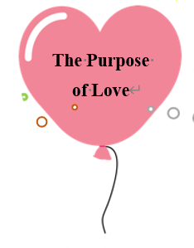
Because other people are doing it?
To seek romance?
To show off?
To find a lifetime partner? To build a family?
To satisfy curiosity?
Don’t want to be alone?
To show that you have grown up?

In Worksheet 1, we have learned about the similarities and differences between friendship and love. As they grow up, young people begin to develop an interest in the opposite sex and long for love relationships. Before love comes, it is important for young people to understand the purpose of love. Love itself is an enjoyable thing in life. During the process, one loves someone and feels being loved. Some people think that love is about getting to know oneself, cherish, support and affirm oneself; some think that love is about learning to give, respect and care for each other; some think that love is about helping each other grow up; some think that love is about spending time with a person in order to confirm that one could make a lifelong commitment to that person.

Source: Excerpted and adapted from Headline Daily News (18 February 2019), Academia Promotes Love Education to Help Build a Healthy Love Concept.
Activity 1: Love is...
Based on the above knowledge content on the purpose of love and personal opinions, answer the following questions:

Based on your understanding of love and your personal opinions, answer what love is in words, a drawing, a concept map, etc. You can use love quotes, plots in TV, film and comic book episodes, songs, quotations, key words, model examples and symbolic objects to express your ideas about what love is.

Love is?
E.g:
- Love does not tolerate perfection. Love is the tolerance of imperfection;
- Love is the five tastes, including sweet, sour, bitter, spicy and salty.

Reflection questions:
- What do you think are the reasons people long for love/fall in love?
- A love relationship is the preparation for marriage in the future. It is the process of finding a lifelong partner.

- Some people think that not having experience in a love relationship means that the person is not up to date or even immature. Do you agree? Why?
- No. Although young people are having love relationships at an earlier age, if they do not have a proper idea of love relationships and are not prepared for love relationships, they will easily have problems in their love relationships and may even end them rashly, hurting the feelings of both parties. On the contrary, we should take a cautious approach to love relationships and learn the right way to be in love and to get along with each other.

- What are the impacts of having an incorrect attitude towards love relationships on young people?
- If young people are not prepared for love relationships or long-term commitment to love relationships, their idea of love relationships may be easily distorted. For example, they may think that being in a love relationship is just a way to prove their maturity or a way to show off, with the result that they may ignore the elements of love such as respect, intimacy and commitment, and possibly hurt each other's feelings.

Teaching reminders:
When the teacher conducts debriefing, he/she should point out the proper values learned from the topic, that is upholding the right principles is particularly important in love relationships, and explains to students the following important points:
- Give up the thinking that our friends have boyfriends/girlfriends, and so we want a boyfriend/girlfriend too;
- Love relationships are not as simple as love at first sight but require devotion and learning.

Knowledge content 2: Proper principles and attitudes towards love
1.1 The principles of love



Maintaining a long-term and successful love relationship is a challenge for many people, and various difficulties and temptations will inevitably arise in the process. It is especially important to choose the right partner. There is no set of correct skills to deal with unpredictable love, but we can learn to choose and cherish the right partner by sticking to our own principles and bottom lines, so that both parties can be respected on the road of love and avoid falling into love traps.
Be clear
Let others know
People
Know
Source: Excerpted and adapted from Liberty Times (22 June 2018),
Recognise. People. Knowing. Understanding The 4 Principles of Love.

Activity 2: The game of the scale of love principle

How to play:
The teacher or a student reads out some controversial statements about love relationships. After listening to one statement, students have about 15 seconds to think about their personal position. They then choose a position to best express their standpoint on the view described in the statement. Students should be open-minded in expressing their views and do not need to blindly agree with others.

* Students shall be invited to discuss views in groups.

Strongly Agree Agree Disagree Strongly Disagree

Some controversial views about love:
- Nowadays, everyone is in a love relationship, so if I am single, I look strange and will be teased by others. If I want to be accepted by my classmates, I should be like everyone else.
- Marriage is the grave of love. Those married want to be free and want to get rid of marriage, while people who are not married think that marriage is a blessing and want to get married.
- There is true love in this world and there will be a destined person waiting for me to spend my life with.
- A person will only be abandoned if he/her is not good enough.
- It's too early! Secondary school students should not be in love.
- Checking in regularly and letting your lover check your phone is a person’s responsibility in a love relationship.
- Love is a relationship between two people. It doesn't matter whether it has the blessing of others or whether they know about it or not.
- It is very romantic to start a relationship at first sight.
- As long as you follow your feelings and go for it, you don't have to worry about the other person's flaws/problems.
- If you don't like each other, you should choose to end the relationship.
- To marry someone who has similar social and economic background is the foundation of a happy marriage.

1.2 Maintaining love relationships
As stated in Worksheet 1, there are three elements that make up a perfect love. Apart from passion, it also requires the emotional commitment of both persons in love and a commitment to develop a trusting and supportive relationship with each other. The right attitude towards love helps us maintain our relationships, ease conflicts and tension, and build longer and deeper relationships. Specifically, we should adopt the following positive attitudes in relationships, including a focus on spiritual exchange, communication, mutual support, equal respect, trust, honesty, compassion, love and care.

We should not start a love relationship hastily when we see that all our friends have boyfriends/girlfriends. Instead, we should first understand our need for a love relationship, our expectations and requirements for the love relationship, and fully consider the feasibility of developing a relationship with someone before making a decision. When choosing a partner, we should not only consider the appearance of the other person, but also the inner qualities, manners and values. The key to getting along with someone is being able to associate with someone closely and the ability to communicate spiritually.

We can increase our contact and communication with someone through group activities or volunteer work, and observe and understand his/her personalities, interests, hobbies and values. We should avoid meeting someone alone in a romantic atmosphere, which may lead to irrational thinking and affect our own judgement. We should not force someone to accept us, nor should we hastily accept love appeal from someone before we have a clear understanding of his/her inner qualities and values.

1.3 Tips for love relationships
The following table lists some descriptions and examples of positive attitudes towards love relationships.
Positive attitudes towards love | Descriptions | Examples
  Communication | - Increase the chance of direct communication between the two  - Use less social media  - Give each other time to calm down during disagreements or arguments | - Seek opportunities to meet face-to-face, enjoy dining out or outing  - If there is misunderstanding, you might as well take the initiative to call to explain, or even make it clear in person  - Give each other time to calm down during a quarrel
  Respect | - Respect each other's uniqueness  - Respect each other's feelings and privacy | - Express appreciation for the other person’s efforts, such as saying thanks and giving hugs, to make the other person feel accepted  - Consider whether the conversation will hurt and offend the other person before speaking  - Don't interrupt the other person's speech, don't be in a hurry to deny or focus on who is right or wrong  - Avoid peeping at the other person’s phone or social media accounts without consent
  Trust | - Trust the other person to be sincere, who will love and care for us  - Believe in the other person even when there is not sufficient evidence to back it up | - Be willing to show the true side of yourself to the other person, and believe that the other person will love you as always  - Do not doubt or tempt your partner based on other people's words or social media information alone  - Keep secret for the other person, and will not disclose his/her secrets rashly
  Honesty | - Express your feelings frankly  - Share your feelings in a safe and trustworthy environment  - Avoid expressing emotions to the other person in an indirect way to reduce misunderstanding | - Express feelings and expectations about events directly  - Talk to each other in the park  - Avoid relying on social media for communication
  Considerate | - Be considerate of the differences in everyone's growth, experience and personality  - Understand each other's ideas and positions, keep an open mind and listen to each other's point of view  - Find a balance point that is acceptable to each other | - Be considerate of each other's difficulties and avoid arguing over unimportant things  - Avoid using negative verbal responses or cynicism when the other person makes a mistake  - Encourage the other person to pay more attention in the future or express willingness to work together
Source: Excerpted and adapted from the Hong Kong Federation of Youth Groups (2018), Love in the i Generation” Teenager's Love View Survey; (2019a), Teaching Kit on ‘The Value of Love.
Activity 3: Tips for love relationships
Learning and teaching reminders:

Teachers should adopt a prudent and objective attitude, as well as listen and understand students’ needs, doubts or difficulties open-mindedly and carefully, to help students discuss the topic of gender issues with a responsible attitude and to enable students to construct a proper understanding of love and understand responsible intimate relationships by analysing relevant learning scenarios and listening to teachers’ debriefing.
Teachers should remind students that when they encounter personal problems, they can seek help and suggestions from professional counselling, teachers, social workers and family members.

Discussion:
In groups of four, students shall discuss the following cases and complete the table below. Provide appropriate tips and methods for love relationships and put a “” to indicate the related appropriate values or attitudes.
 | Case | Tips/Methods for love relationships | Appropriate values/Attitudes
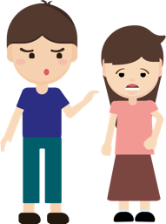 | Siu Ka invited his girlfriend Siu Fun to a friend's birthday party. After dinner, people at the party said they would go singing together. At this point, Siu Fun told Siu Ka that she wanted to go home to prepare for the exam and asked if he could leave with her. Siu Ka felt that Siu Fun was not giving him face and had a quarrel at the scene.sre | - Considerate: Be considerate of Siu Fun's wish to study for examinations and Siu Ka's wish not to spoil the fun. Try to find a balance, e.g. they can go home together after playing for a while or Siu Fun can go home first to study. | - Rationality  - Self-reflection  - Responsibility  - Respect  - Tolerance  - Caring  - Trust  - Empathy  - Mutual support  - other:_________
 | Siu Mei likes to browse social media to keep track of her friends' latest news. Once, Siu Mei saw that Siu Chun had uploaded a photo of herself and Siu Wai together, and she remembered that Siu Wai said he had gone to play football that day. She began to wonder if he was hiding something from her and was very suspicious of his every word and behaviour. | - Trust: Don't be suspicious of Siu Wai based on social media contents alone. When you feel uncomfortable or doubtful, you should ask your partner directly to avoid allowing feelings of uneaseness and suspicion to grow. | - Rationality  - Self-reflection  - Responsibility  - Respect  - Tolerance  - Caring  - Trust  - Empathy  - Mutual support  - other:_________
 | Siu Yin likes to try new things and does not like to live a rigid and boring life. She is often dissatisfied with her boyfriend Siu Ho's refusal to try new things, such as clothing, food choices and hobbies, and has repeatedly accused him of being conservative and boring, and even shared this with her friends as a joke. | - Respect: They should respect each other's uniqueness, and even if they have different views on trying new things. Siu Yin should not criticise or tease Siu Ho, but appreciate his respect and long-lasting love for traditional food and objects. | - Rationality  - Self-reflection  - Responsibility  - Respect  - Tolerance  - Caring  - Trust  - Empathy  - Mutual support  - other:_________
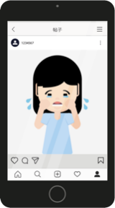 | Siu Yuk recently ignored Siu Kwong because Siu Kwong had forgotten their three-month dating anniversary and did nothing about it. After the incident, Siu Yuk expressed her unhappy feeling through social media, attracting a lot of concern and sympathy from people, which puts a lot of pressure on Siu Kwong. | - Communication: Avoid using social media to express feelings. Instead, Siu Yuk shall express to Siu Kwong in person her disappointment that he had forgotten their dating anniversary and avoid using peer pressure to embarrass Siu Kwong. | - Rationality  - Self-reflection  - Responsibility  - Respect  - Tolerance  - Caring  - Trust  - Empathy  - Mutual support  - other:_________
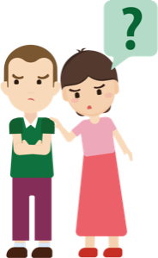 | Recently, Siu Wah has been troubled by his father's unemployment and his mother's illness. He is used to taking care of everything by himself and does not like to share his worries with others. He always shows his optimistic and strong side to others, even in front of his girlfriend Siu Kwan. Recently, Siu Kwan noticed that Siu Wah was different and asked him several times, but he said, “I can handle it, trust me.” Siu Kwan felt worried and lost. | - Honesty: Siu Wah can share his worries with his girlfriend Siu Kwan to avoid making her worry about him. Even if Siu Wah is reluctant to disclose details of his situation, he can still frankly share his feelings with Siu Kwan. In doing so, Siu Kwan will understand his situation and it can also help relieve Siu Wah’s stress. | - Rationality  - Self-reflection  - Responsibility  - Respect  - Tolerance  - Caring  - Trust  - Empathy  - Mutual support  - other:_________

Learning and teaching reminders:
When the teacher conducts debriefing, he/she should point out the proper values learned from the topic, including rationality, self-reflection, responsibility, inclusiveness, care for others and mutual support, etc., are very important in maintaining love relationships; and should explain to students the following important points:
- Uphold proper attitudes including communication, respect, trust, honesty and consideration, etc. and they can help resolve love conflicts.

Summary
As young people grow up, it is natural that they become curious about sex and long for love relationships. In today's society with abundance of information, young people can receive different messages about love relationships and sex through various media at any time and in any place, prompting them to fantasise and long for love relationships.

However, as young people are still developing, their preferences, perceptions and values will change over time. It is therefore not advisable to choose a partner rashly or prematurely and miss the chance to broaden their social circle or interpersonal relationships. The purpose of a love relationship is to enable one to learn how to get along with others through spending time with someone, and to get to know oneself and grow up with the loved one together.

As young people do not have enough experience in life, it is easy for them to act blindly and unwisely in love relationships. For example, they may over-glamorise their loved ones, make them the centre of life, become absorbed in their own world and neglect their studies or contact with family and friends. Or, if they are getting too involved, they may be prone to emotional ups and downs and even radical behaviours due to problems between themselves.

Love is not blind. It is built on sincere and honest spiritual communication, as well as mutual love and respect. Having a positive attitude towards love relationships should bring mutual benefits, contribute to personal growth, broaden knowledge and horizons, and lead to progress in interpersonal and family relationships and studies, rather than putting the cart before the horse and having negative effects on oneself or others.


Module 3.1 Intimate Relationships with Affection and Propriety
Part 1: Proper understanding of love in adolescents
(Lesson 3 and Lesson 4)
Learning and Teaching Materials

Worksheet 3: Understanding the factors that lead to the end of a love relationship and the appropriate way to handle it
In Worksheet 2, we know the purpose of love relationships and the attitudes and principles that should be adopted. A fulfilling love relationship meets our emotional needs and provides comfort to the soul through mutual sharing and support. However, when a love relationship has turned sour and reached a point where it cannot be mended and the problems cannot be solved through communication and compromise, ending the relationship may be an appropriate solution. However, many young people feel at a loss when faced with conflicts in love relationships and are resistant to end the relationships. They often refuse to accept the reality and delay solving the problem.

A survey on teenagers' handling of relationship break-ups found that the average teenager had experienced four break-ups, with more than half of the respondents reporting that their most painful break-ups had occurred between the ages of 14 and 15. This shows that there is a need for young people to learn about the factors that lead to relationship break-ups, how to deal with them and how to adjust their mindset after a break-up.

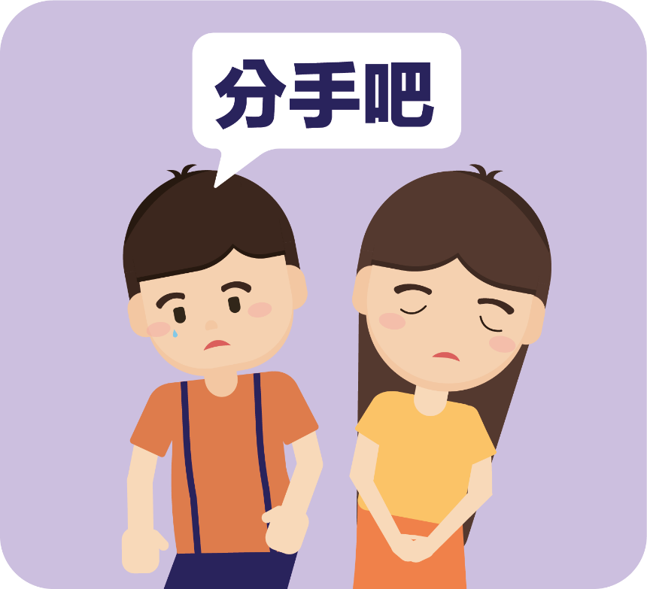
Let’s break up



Knowledge content 1: Factors that lead to the end of a relationship
Where there's a beginning, there's an end. The following are some of the most common factors that lead to the end of a relationship.









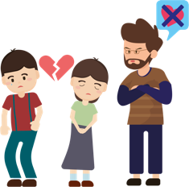

Sources: Excerpted and adapted from Hong Kong Federation of Youth Groups (2019b), Gender Relations and Values; Breakthrough Limited (2000), A Study of Adolescent Emotional Life.

Activity 1: Breaking up properly
Learning and teaching activity suggestion: The teacher may choose to discuss different cases in class. Cases that are not discussed can be used as homework to consolidate knowledge.

Learning and teaching reminders:
Teachers should adopt a prudent and objective attitude, as well as listen and understand students’ needs, doubts or difficulties open-mindedly and carefully, to help students discuss the topic of gender issues with a responsible attitude and to enable students to construct a proper understanding of love and understand responsible intimate relationships by analysing relevant learning scenarios and listening to teachers’ debriefing.
Teachers should remind students that when they encounter personal problems, they can seek help and suggestions from professional counselling, teachers, social workers and family members.

Read the following cases carefully and answer the related questions.

Case 1: Resentful of being dumped, a young woman slapped her boyfriend in jealousy and left

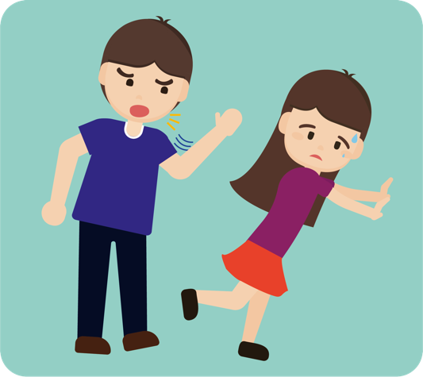
Siu Wai and Siu Keung had been dating for about a year. During the relationship, Siu Wai argued with Siu Keung from time to time because of his shortcomings and carelessness, and even insulted and was rude to him. In the end, Siu Keung could not tolerate and break up with her. After the break-up, Siu Wai felt unhappy and thought that he had ended the relationship because he had a new lover. She followed him after school every day and once forced him to go to a restaurant to talk to her, asking him to clarify things before letting him go home. He said he wanted to deal with his relationship rationally, but when she saw a female friend calling him on the phone during the conversation, she became jealous and started acting rudely. Siu Wai explained that she simply wanted to talk to him about getting back together, and that she had always been very nice to him and would usually treat him to food and gifts.

Based on the above information and personal opinions, answer the following questions:
- What is the problem between Siu Keung and Siu Wai?
- Siu Wai was dissatisfied with Siu Keung's carelessness and shortcomings, and even insulted and was rude to Siu Keung.

- What do you think are the factors that led to their break-up?
- Failure to communicate: There were conflicts in their relationship, and most of the conflicts were caused by the way they communicated and expressed themselves. For example, Siu Wai often responded with rude and improper attitudes. This was unbearable for Siu Keung.
- Failure to meet emotional needs: The conflicts persisted, making it difficult for them to maintain their initial passion and commitment to each other, and the relationship went cold and came to an end.

- Was Siu Wai' s attitude and behaviour towards Siu Keung's suggestion of breaking up appropriate?
- No. Siu Wai was resentful of Siu Keung's suggestion of breaking up and thought that Siu Keung had a new lover. She did not reflect on the fact that they had already had disagreements. After the break-up, Siu Wai acted inappropriately by following Siu Keung after school every day and forcing Siu Keung to talk to her.

- What are the differences in the methods used by Siu Wai and Siu Keung to handle the end of their love relationship? Do you think their methods helped solve the problem? Why?
- Methods used: Siu Keung wanted to deal with his love relationship with Siu Wai in a rational way, while Siu Wai chose to follow Siu Keung after school and force him to have a conversation with her.
- Effectiveness: I don't think the method used by Siu Wai helps solve the problem. Her radical approach to the relationship problem not only fails to bring about rational communication and mutual discussion to work out solutions together, but makes the other party feel scared and resentful.
- Although Siu Keung wanted to solve the problem rationally, he had not yet mastered the necessary communication skills and without the help of others, it could easily lead to adverse results and even put himself in a dangerous situation.

- If you were Siu Wai's friend, how would you advise her to handle the love relationship with Siu Keung appropriately?
- I would advise Siu Wai not to hurt others when dealing with her love relationship with Siu Keung, and to understand calmly why Siu Keung wanted to break up with her. Furthermore, since they were not able to solve the problem between them on their own, I would advise Siu Keung to work out the problem with Siu Wai with the help of friends or other persons he trusted, and avoid meeting with Siu Wai alone or behaving in a disrespectful manner.

Case 2: Trapped in emotional distress, drunken Siu Ming collapsed
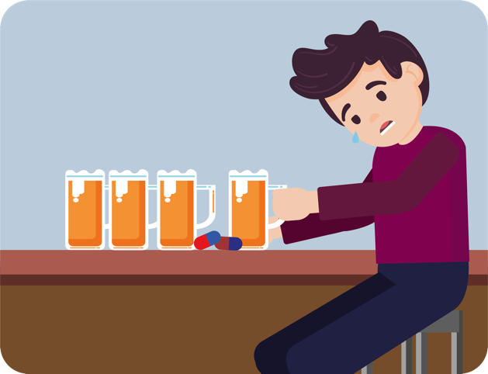
Siu Ming and Siu Mei had a relationship problem recently. Siu Mei thought that Siu Ming was not serious about their love relationship. They had totally different expectations and values. Siu Mei thought that Siu Ming had not taken care of her feelings and tried to understand her, and had not planned well for the future, and hoped to change Siu Ming. However, Siu Ming felt that he was truly committed to her and hoped that Siu Mei could respect his uniqueness and character. In the end, Siu Mei honestly told Siu Ming that she wanted to break up with him and be friends with him again, but Siu Ming found it hard to accept the suggestion of breaking up and cried bitterly. As his family had always opposed to Siu Ming having a love relationship too early, he dared not tell his family about his relationship problem. Siu Ming thought that Siu Mei did not understand his dedication and determination to their love relationship, and he turned to alcohol to cope with his sorrow.

Based on the above information and personal opinions, answer the following questions:
- What kind of relationship problem did Siu Ming and Siu Mei have?
- Their expectations about their love relationships are different. Siu Mei feels that Siu Ming does not take their love relationship seriously, has no plans for the future and is unwilling to change for her. However, Siu Ming feels that he has given his heart to their love relationship and feels that Siu Mei has not respected his uniqueness and character.

- What are the differences in the methods used by Siu Mei and Siu Ming to solve their relationship problem? Do you think their methods are helpful in solving their relationship problem? Why?
- Methods used: Siu Mei wanted to change Siu Ming to meet her own expectations, but unfortunately, she was unsuccessful and chose to break up with Siu Ming, thus losing the opportunity to solve the problems together.
- Effectiveness: Siu Ming was unable to accept the break-up and cried bitterly, and turned to alcohol to cope with his sorrow. However, this did not help solve the problem.

- If you were Siu Ming's friend, how would you advise him to handle the love relationship with Siu Mei appropriately?
- I would encourage Siu Ming to express his feelings and worries more, not to face the sadness alone, and to seek advice and support from someone he can trust when needed. I would also suggest that Siu Ming should try to communicate with Siu Mei, explaining that he is facing pressure from his family, but is willing to make improvements to meet her expectations, and hopes that Siu Mei will give him time to make improvements.

Case 3: Proposed to break up with girlfriend who has another boyfriend, being harassed by 60 abusive text messages a day

Siu Ho could not tolerate that his girlfriend Siu Sin had another boyfriend, so he told Siu Sin that he wanted to end the relationship. She was unable to accept the truth and kept on harassing him with phone calls and text messages. Siu Ho repeatedly told his friends in chat groups that he was depressed and under a lot of pressure.

Siu Sin had once gone to Siu Ho's classroom during recess and lunch to scold him, and even tried to scold him on the road near the school. Siu Ho had tried to approach Siu Sin's family, hoping that they would discuss with Siu Sin and help ask Siu Sin to stop harassing him. He also showed screenshots of text messages to Siu Sin's family to let them know about Siu Sin's bad behaviours, such as abusing Siu Ho by saying “you are short” and “you are a useless person”. Her message also said “I'm sure I can find a better one”. However, Siu Sin's family thought that their love relationship was a matter between them which they had no control and just told Siu Ho to handle it themselves.

Source: Excerpted and adapted from Hong Kong Economic Times (31 December 2019), Female college student can't bear her boyfriend cheating and breaking up, receiving 60 abusive text messages a day, harassing and jumping off the building.

Based on the above information and personal opinions, answer the following questions:
- What kind of a relationship problem did Siu Ho and Siu Sin have?
- Siu Ho could not tolerate that his girlfriend Siu Sin had another boyfriend, so he suggested to end the relationship.

- Was Siu Sin's attitudes and behaviours towards Siu Ho's suggestion of breaking up appropriate?
- No. Siu Sin could not accept the truth of breaking up and kept on harassing Siu Ho with phone calls and text messages, which made Siu Ho feel pressured, and Siu Sin’s behaviours had affected Siu Ho’s daily life.

- What are the differences in the methods used by Siu Ho and Siu Sin to deal with the end of their love relationship? Do you think their methods helped solve the problem? Why?
- Methods used: Siu Sin used harassment and verbal abuse in the hope that her boyfriend would change his mind, but this approach did not help solve the problem. Instead, she put more pressure on Siu Ho, who became increasingly depressed and more determined to end the relationship.
- Effectiveness: When faced with the problem, Siu Ho tried to talk to his friends and tell Siu Sin's family, hoping that they could help mediate the situation. His friends’ listening could help relieve Siu Ho’s pressure. However, Siu Sin’s family did not want to get involved, talking to them cannot help solve the problem.

- If you were Siu Sin's friend, how would you advise her to handle her love relationship with Siu Ho?
- I would encourage Siu Sin not to use harassment and verbal abuse to express her discontent with Siu Ho’s suggestion of breaking up. She should rationally consider the cause of problem in their relationship (i.e. the fact that she had another boyfriend) and should not act in a way that hurt Siu Ho. If necessary, she should seek help from others to find a solution.

Knowledge content 2: Appropriate methods to handle ending of a love relationship
When a love relationship has turned sour and reached a point where it cannot be mended, ending a relationship rationally may be a right solution. There are many considerations, feelings and thoughts that come up when we break up a love relationship, and we hesitate to make a decision due to reluctance, love or fear, which can end up causing more harm than good. In a love relationship, we need to take responsibility for our own actions and decisions, as well as consider and respect the feelings of the other person. The 5W1H helps us calmly analyse what has happened in a love relationship, the reasons and processes that lead to the break-up, and to assess where, when and who would be the best person to help end the relationship.
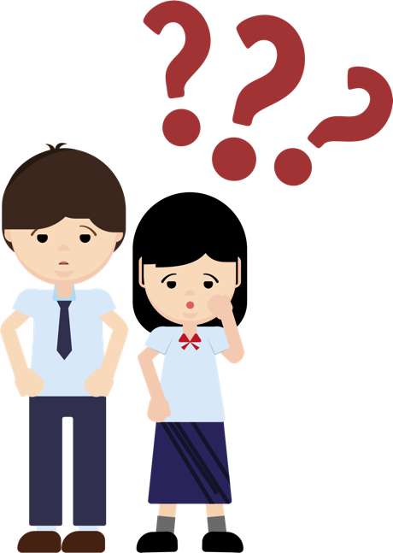

Figure 2 5W1H to end a love relationship

5W1H to end a love relationship
5W1H | Sentence pattern | Content | Example
What | What causes a love relationship to end? | - Are there recent/ongoing conflicts?  - Are there any signs for a break-up? | Having fights several times a week, feeling stressed, even affecting schoolwork and daily routine
Why | Why end a love relationship? | - Have people involved ever tried to solve the problem?  - Is the problem so serious that the relationship is to be ended?  - Is ending a relationship the most appropriate solution right now? | Different views on how to deal with the love relationship, one party wants to solve the problem rationally, but the other party just keeps arguing
How | How did you propose to end a love relationship? | - Is it appropriate to speak clearly face to face?  - Do I need to delete all contact and communication records? | Write a letter and give it to the other party in person, let the other party read it first and then further explain it
Who | Who is suitable to help end a love relationship? | - Have friends/teachers/family members been asked for advice?  - Do you tell someone you trust about details of your plan before breaking up?  - Is it suitable to meet alone, or need someone to accompany and support? | Discuss with friends;  Inform parents in advance where and when you will meet each other
When | When is a good day to propose ending of a love relationship? | - Did you give the other party enough time to digest and make psychological preparation?  - Is it too sudden or should you pick an important festival to break up?  - Is there a cooling-off period and a buffer period for the other party to deal with the problem? | Try to avoid time close to festivals or anniversaries; Prefer to meet at noon on weekends
Where | Where is the right place to suggest ending of a love relationship? | - Are there any dangerous facilities near the place where you meet the other person?  - Is it easy to find help if needed? | Meet to discuss in a restaurant in a busy area

Appendix 3
Know more: The Break-up agent

Back in 2006, a German company (Schlussmachen) advertised that it would help clients with break-ups. The company claims to help clients with break-ups in just three minutes for a fee of around €30, through various methods such as phone calls and face-to-face meetings. In Canada, there have been similar online companies in recent years that specialise in handling love relationships for their clients in similar way as the German company mentioned above. This company emphasises that its staff are break-up specialists to ensure that the quality of service is guaranteed. These companies specialise in break-ups, and will tailor-make individual plans for their clients, using a mediator model to help couples deal with their break-up in a more indirect and peaceful manner, according to the personalities and relationship status of both parties. Some of the companies are not only targeting young people with little relationship experience, but are also starting to develop their services for the upper class and third parties.

Sources: Excerpted and adapted from Breakup Shop (2020), Bad breakup? We're here to help; Schlussmachen (2014), Ihre Beziehung beenden! Einfach Schlussmachen!.
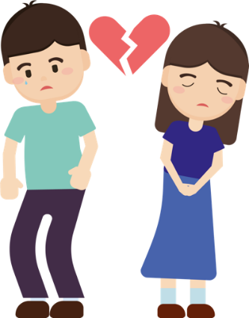

Why do some people choose to use agent break-up services?
What are the advantages and disadvantages of this method?
Activity 2: Break-up assessment report
Learning and teaching activity suggestion: The teacher may choose to discuss some cases in class. Cases that are not discussed can be used as homework to consolidate knowledge.

Teaching reminders:
Teachers should adopt a prudent and objective attitude, as well as listen and understand students’ needs, doubts or difficulties open-mindedly and carefully, to help students discuss the topic of gender issues with a responsible attitude and to enable students to construct a proper understanding of love and understand responsible intimate relationships by analysing relevant learning scenarios and listening to teachers’ debriefing.
Teachers should remind students that when they encounter personal problems, they can seek help and suggestions from professional counselling, teachers, social workers and family members.

If you are a break-up agent, read the following cases carefully, fill out a break-up assessment report, and suggest appropriate handling methods.
Case 1
Siu Lan and Siu Fung have been dating for over a year. Siu Fung loves to play video games. Siu Lan sends messages and calls to Siu Fung, but Siu Fung does not pay much attention to her. At times, she feels as if she lives alone. She is also dissatisfied with Siu Fung for not keeping his promises and even blames her for meddling and demanding. Siu Lan and Siu Fung quarrel at least once a week. Siu Fung feels that there is nothing wrong with their relationship, but Siu Lan feels that it is time to end the relationship and wants to send a message to inform Siu Fung of her decision, but she wonders if it is appropriate. Can you help her?


Break-up assessment report
Client’s name | Siu Lan
Client’s feelings  when faced with the relationship problem | Siu Lan feels sad that despite her efforts and dedication, she does not get a positive response from Siu Fung and does not feel loved. At the same time, she feels helpless, thinking that there are many problems in their relationship, but the other party does not take it seriously and she is blamed for meddling. She feels disappointed and thinks it is time to end the relationship.
Method(s) used by client to deal with the problem | Siu Lan tried to communicate with Siu Fung in different ways, but received no positive response. Siu Lan also tried to deal with the problem between her and Siu Fung, but Siu Fung thought there was no problem and that she was just making a big deal out of it. In the end, Siu Lan wanted to send a message to inform Siu Fung of her decision to break up with him.
Your professional opinion  (Do you agree with the client’s way of handling the problem? Why?) | I do not agree with Siu Lan’s way of handling the problem. It is easy to cause misunderstanding just by sending a message to inform Siu Fung of the break-up. In doing so, it is also difficult to understand Siu Fung’s emotions. Besides, Siu Fung usually does not pay much attention to Siu Lan's messages, so sending messages to inform him of the break-up is probably not an appropriate way of communication.
Client’s attitude towards solving the problem  (Is the client’s attitude towards solving the problem positive or negative?) | Siu Lan has always been positive about solving the problem in the relationship and has repeatedly tried to talk to Siu Fung rationally to solve the problem, but Siu Fung did not realise the seriousness of the problem, which is why she decided to break up with him.
Client’s preference  (Does the client want to maintain the relationship or end it? If the relationship is maintained, what situation will the client face?) | Siu Lan wants to end the relationship. If the relationship is forced to continue, it will only continue to disappoint her and break her heart, and the negative emotions will continue to affect her life.
Your comments / your feelings | I think Siu Lan has tried to deal with problem in the relationship with Siu Fung in a positive way, but her emotional needs were not met due to the different views and values of both parties. This reminds us to be careful when choosing the right partner to avoid feeling overwhelmed and lost in the love relationship.
Your recommendation | Break up Maintain
Handling break-up scenario
Main reason for the break-up recommendation | There is a clear difference in views and values between them and they have not been able to narrow their differences and improve their relationship.
Best way to put the recommendation into action | We recommend that both parties share their thoughts and feelings peacefully and in a face-to-face manner and give each other time to digest the break-up.
When? | Daytime.
Where? | Public place.
Whether client will need help from others | Siu Lan may ask the teacher for advice or ask a friend to accompany her if necessary.
Signature: | Date:

Case 2
Siu Ching and Siu Lam have always been a model couple in the eyes of others, and they are very much in love in front of others. But there have been conflicts between them for a long time. Siu Ching blames Siu Lam for being jealous and insensitive. After a quarrel, Siu Ching hopes that they can separate and calm down their emotions and find a rational solution. However, Siu Lam thinks that Siu Ching is using “cold violence”, attacking him with coldness and indifference and expressing her displeasure through silence. So, apart from maintaining the image of a model couple in front of people, they both choose to escape and stay silent at all times. They even think that one will win in the relationship if one can hold on until the other one gives in. What advice would you give to Siu Ching?


Breakup assessment report
Client’s name | Siu Ching
Client’s feelings  when faced with the relationship problem | Siu Ching feels conflicted and tired about the current situation. There is problem in her relationship with Siu Lam, but they still has to pretend to be in love with each other in front of people.  She is disappointed with the way they are getting along. She tries to ease the problem by rational means, but is not accepted by Siu Lam and her way of handling the problem is perceived as trying to use cold violence.  Feeling helpless, she can only respond with avoidance and silence.
Method(s) used by client to deal with the problem | Siu Ching has tried to solve the problem with Siu Lam in a calm and rational manner, and hopes to avoid disclosing their problem. When her method does not work out, she has to deal with the problem in a passive and evasive manner.
Your professional opinion  (Do you agree with the client’s way of handling the problem? Why?) | I do not agree with Siu Ching’s way of handling the problem. Siu Ching tries to deal with the problem by separating to calm down the emotions and to seek a solution, but it is misunderstood by Siu Lam who thinks that Siu Ching is not sincere in solving the problem.  She can set up a cool-off period for both parties to calm down before actively addressing the problem in the relationship and finding a solution.
Client’s attitude towards solving the problem  (Is the client’s attitude towards solving the problem positive or negative?) | The problem has not yet been solved, and now Siu Ching can only avoid Siu Lam in a passive manner, hoping that he will lose patience and choose to compromise. However, their basic problem have not been solved positively.
Client’s preference  (Does the client want to maintain the relationship or end it? If the relationship is maintained, what situation will the client face?) | Siu Ching wants to maintain the relationship and also wants to win the argument so that Siu Lam will act according to her wishes. If the relationship is maintained without solving the problem, she will be faced with a situation in which she has to pretend to be very much in love with Siu Lam in front of people but feels annoyed afterwards. Prolonged period of conflicts and fights will hurt feelings and damage the love relationship.
Your comments / your feelings | I think that conflicts and arguments are inevitable in a love relationship and it is important to get both parties to agree on a solution. For example, not everyone prefers dealing with a relationship problem by first separating and then working out a solution calmly. Some people prefer discussing a problem as soon as it arises to avoid complication. Therefore, it is important that people involved in a love relationship to communicate with each other in a rational, honest, respectful and tolerant manner to work out solutions to their problems . In fact, being the winner in a quarrel does not help improve the relationship.
Your recommendation | Break up Maintain
Handling the break-up scenario
Main reason for the break-up recommendation | Not applicable
Best way to put the recommendation into action | Not applicable
When? | Not applicable
Where? | Not applicable
Whether client will need help from others | Not applicable
Signature: | Date:
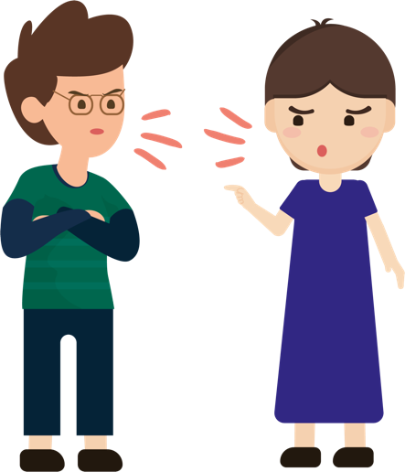
Case 3
Siu Mei and Siu Sze fell in love at first sight and soon started to develop a passionate relationship which, despite some conflicts, has lasted all this time. Siu Sze enjoys spending time with Siu Mei and is attracted to her in many ways. He likes that he can show his true self to Siu Mei. But Siu Mei thinks Siu Sze is too childish, like a little boy who never grows up. Whenever she talks about something serious, he always responds in a playful way and she often has to give in to him. Siu Mei is tired of this. She thinks that since there is no future for them, it would be better to break up with Siu Sze sooner rather than later. She is worried that she has not done enough to resolve their differences and is not sure if it is the right time to end their relationship.


Breakup assessment report
Client’s name | Siu Mei
Client’s feelings  when faced with the relationship problem | Siu Mei feels tired and insecure. She cannot accept Siu Sze's personality and communication style, and she has to give in to him all the time. She hopes that her partner is more mature and will plan for their future.  She feels lost and suspects that she has not made an effort in the relationship and therefore feels guilty every time when she thinks about breaking up with Siu Sze.
Method(s) used by client to deal with the problem | Siu Mei has tried to communicate rationally with Siu Sze, hoping to narrow down the differences between them and even accommodate Siu Sze’s personality. No doubt these efforts have reduced the number of conflicts, but they have not resolved Siu Mei's doubts about the relationship.
Your professional opinion  (Do you agree with the client’s way of handling the problem? Why?) | I agree with Siu Mei's solution (to communicate with Siu Sze in a rational way). They have been in love for a long time, and it is inevitable that they will overlook each other's shortcomings due to the passion. However, Siu Mei is already planning for the future and is aware of the hidden problem in the relationship. It would be better if they could solve the immediate problem as soon as possible through rational communication.
Client’s attitude towards solving the problem  (Is the client’s attitude towards solving the problem positive or negative?) | Siu Mei takes a positive approach to solving the problem, but for the time being, she is unsuccessful. Rational communication and making effort to accommodate Siu Sze can reduce conflicts, but it still falls short of her expectations and therefore she has to consider breaking up with Siu Sze.
Client’s preference  (Does the client want to maintain the relationship or end it? If the relationship is maintained, what situation will the client face?) | Siu Mei believes that it is better to have short-term pain than long-term pain and wants to break up with Siu Sze. However, she worries that she has not put in sufficient effort in the relationship. But if she continues with the relationship and the problem is not solved, conflicts will continue to arise and even become more intense; and she might keep forcing herself to accommodate Siu Sze and become more and more frustrated with the situation, to a point when she eventually feels exhausted and lost.
Your comments / your feelings | I believe that a love relationship is based on two-way communication and one partner should not be expected to accommodate and satisfy the needs of the other one-sidedly. Instead, two people should take their relationship in a positive and serious way, respecting and accepting each other's personal qualities. As long as both partners share the same positive attitude, conflicts can be reduced.  At the same time, Siu Mei should express her concerns and worries to Siu Sze more often, so that they can work out a possible solution together.
Your recommendation | Break up Maintain
Handling the break-up scenario
Main reason for recommendation | The love relationship between Siu Mei and Siu Sze falls short of Siu Mei’s expectation. Siu Mei has tried hard to communicate but it seems that Siu Sze will not have great change in the near future.
What? | Since both parties are still in the infatuation stage, we recommend that both parties share their thoughts and feelings peacefully and in a face-to-face manner and give each other time to calm down. After some time, if both parties still think that it is impossible for Siu Sze to reach become more mature and meet Siu Mei’s expectation, they can discuss the best way to end the relationship to reduce the pain for both parties.
When? | Daytime
Where? | Public place
Whether client will need help from others | Siu Mei may ask the teacher for advice or ask a friend to accompany her if necessary.
Signature: | Date:

Conclusion
Young boys and girls entering adolescence begin to develop an interest in the opposite sex and a desire to make friends and develop a love relationship with the opposite sex. However, young people must be aware that love is one of the more intimate relationships between people, and that they need to be cultivated with care in order to thrive. As young people learn to love and be loved, they gradually develop a mature and responsible self, and each love relationship involves a journey that is difficult for others to understand, and which will lead them to reflect and improve to perfect themselves.

In the course of a love relationship, conflicts are inevitable. Ending a love relationship is a chance for both partners to breathe and grow when they can no longer stay happy in the relationship. Whether you are the one initiating or facing a break-up, it is especially important to be rational and honest. Talking to each other openly about the reasons for the break-up will not only reduce resentment and suspicion, but will also allow you to understand yourself, accept each other's shortcomings and learn to cope with life after the break-up. Love is not the whole of life. Break-up is not the end of the world. What is important is that we can reflect on the relationship and learn how to improve ourselves to meet future challenges and develop a more mature relationship.

However, every relationship should aim for longevity and stability. As long as both partners are willing to take time to nurture the relationship by sharing their thoughts; learning to understand, respect and accept each other; being considerate and wanting to give each other happiness; refraining from forcing others to do things that go against their will; and sharing the good times and the bad; and facing setbacks and trials together, a beautiful fairy-tale love relationship is within reach.


References
The Liberty Times (22 June 2018). Recognise. People. Knowing. Understanding The 4 Principles of Love”. https://health.ltn.com.tw/article/paper/1210839
Oriental Daily (27 August 2020). Over 100 years old couple married for 79 years, the oldest living couple in the world https://hk.on.cc/hk/bkn/cnt/amenews/20200827/bkn-20200827230206332-0827_00972_001.html
The Hong Kong Federation of Youth Groups (2018). “Love in the i Generation” Teenager's Love View Survey.” https://hkfyg.org.hk/wp-content/uploads/2018/02/新聞稿_青協公布「愛在i世代」青少年戀愛觀調查結果.pdf
The Hong Kong Federation of Youth Groups (2019a). Teaching Kit on ‘The Value of Love’.
The Hong Kong Federation of Youth Groups (2019b). “Gender Relations and Values." https://hkfyg.org.hk/wp-content/uploads/2019/02/ 新聞稿_青協公布「愛在i世代」青少年戀愛觀調查結果.pdf
Hong Kong Economic Times (27 August 2020). “20 years of friendship remains unchanged youngster with rare diseases take care of friend in wheelchairs every day” https://topick.hket.com/article/2576017?r=cpsdlc
Breakthrough Limited (2000). “A Study of Adolescent Emotional Life.” https://ir.breakthrough.org.hk/btr15/
Headline Daily (18 February 2019). “Academia Promotes Love Education to Help Build a Healthy Love Concept”.
Breakup Shop (2020). Bad breakup? We're here to help. https://breakupshop.com/?fbclid=IwAR0uRQKN5tkv7CeAAMM0mGgc0f4vY5R04CVCoRyu_l7blhr9LA-m-7om-vU
Rubin, Z. (1970). Measurement of romantic love. Journal of Personality and Social Psychology, 16 (2), 265–273. https://doi.org/10.1037/h0029841
Schlussmachen (2014). Ihre Beziehung beenden! Einfach Schlussmachen!
Ward, A. (2012, October 23). Men and women can't be “just friends”. https://www.scientificamerican.com/article/men-and-women-cant-be-just-friends/



